Assignment – State machine
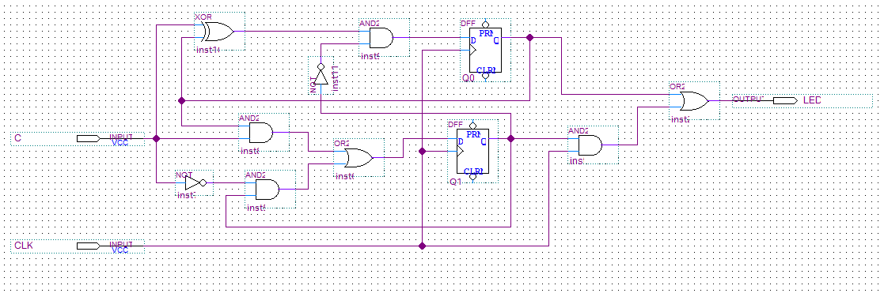
Output decoder:
LED = Q0 + Q1*CLK

Q1 | Q0 | CLK | LED
0 | 0 | 0 | 0
0 | 0 | 1 | 0
0 | 1 | 0 | 1
0 | 1 | 1 | 1
1 | 0 | 0 | 0
1 | 0 | 1 | 1
1 | 1 | 0 | -
1 | 1 | 1 | -
CLK | 00 | 01 | 11 | 10
CLK | 0 | 1 | - | 0
CLK | 0 | 1 | - | 1

C | 00 | 01 | 11 | 10
C | 0 | 0 | - | 1
C | 0 | 1 | - | 0
Input decoder:
$$D1= \overline{C}*Q1+C*Q0$$

Q1 | Q0 | C | D1 | D0
0 | 0 | 0 | 0 | 0 | off
0 | 0 | 1 | 0 | 1 | continues
0 | 1 | 0 | 0 | 1 | continues
0 | 1 | 1 | 1 | 0 | Blinking
1 | 0 | 0 | 1 | 0 | Blinking
1 | 0 | 1 | 0 | 0 | Off
1 | 1 | 0 | - | -
1 | 1 | 1 | - | -
C | 00 | 01 | 11 | 10
C | 0 | 1 | - | 0
C | 1 | 0 | - | 0

$$D0= \overline{Q1}*(C⊕Q0)$$

EDGE DETECTOR:
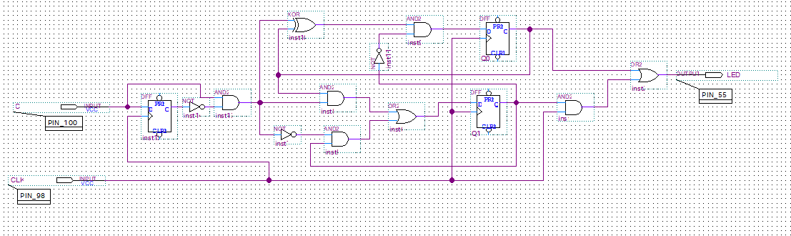
An edge detector is a digital circuit that identifies a change in a signal, typically a transition from low to high (rising edge) or high to low (falling edge). It outputs a single pulse in response to this transition, regardless of how long the signal remains in its new state. This ensures that only one action is triggered per button press, eliminating repeated signals caused by holding the button down.
STATES DIAGRAM:
10
01
00

